**Coursework Report**

Sean Pickles

40318409

Web Technologies (SET08101)

**Introduction:**

The aim of this assignment was to improve upon my website from coursework 1 by setting up a web server and allowing users to register an account and then login with that username and password. Also, by allowing users to register an account on the website they could send and receive ciphers that were previously created as part of coursework 1.

These messages would be sent according the other user’s username stored on the database of my choice This coursework will consist of two main parts – the server routing + setup part and the chosen database.

Server side must be able to allow the user to navigate the website so that it is easy to follow. It must allow a user to create an account and then login with those credentials and hopefully – if I have the time/ability to – only users that users that have an account can view certain pages on the website. The database will store the username and password for the users.

**Software Design:**

The initial design of the server will hopefully fulfil the requirements, outlined by the specification – allow users to create an account and login. When I started attempting this coursework I tried to store the users credentials within local storage, which would mean it would be stored on the client side.

I was advised against this method as it would pose a big security risk as the users details could be accessed at any time by anyone. Instead I opted to try and use sqlite3 as it was part of the labs and there was some stuff online about it to help.

The database will store the username and password for each user. The table that is used to store these will be referred to regularly to check if the user has been registered and if so, then they can login. Also, if that user has already made an account then an announcement will be printed to the console to state this.

Logging into an account will require the user to enter the username and password that they registered with, which will be checked with the current set of data in the database. If it’s the wrong login then the user will be notified.

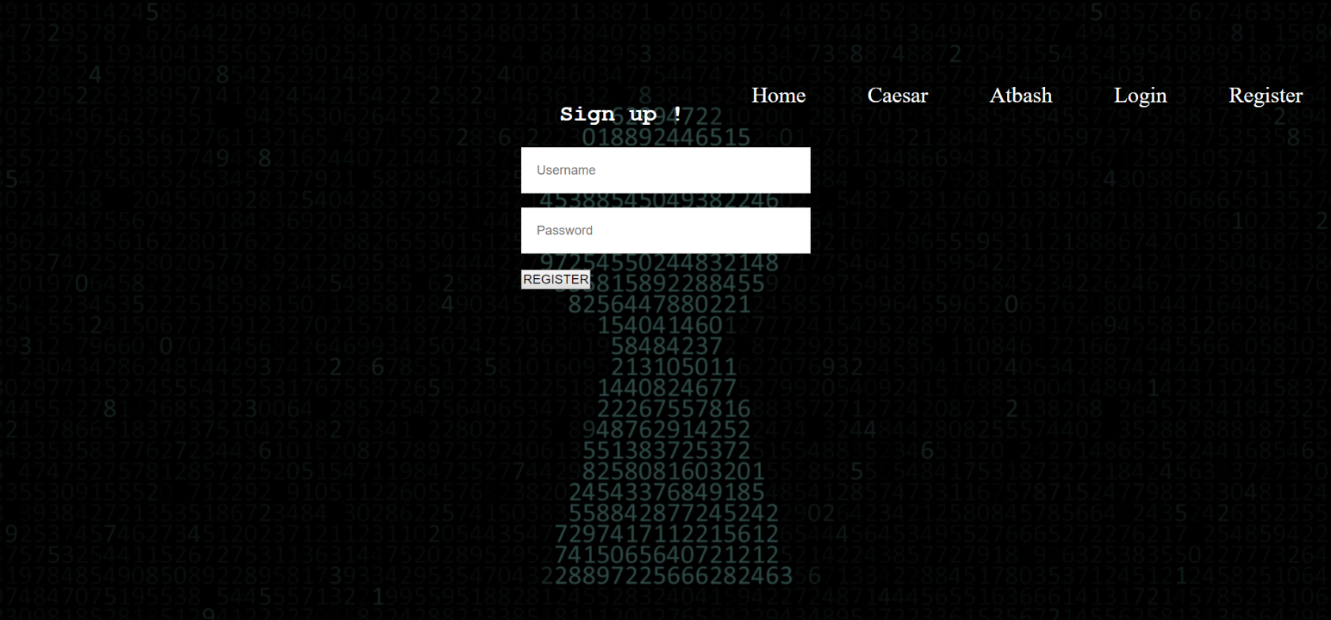

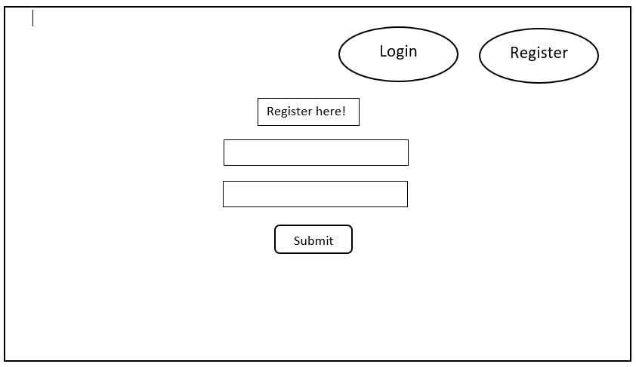

I think my design for this page has turned out about the same as my original design in the wire frame, but overall the overall design hasn’t changed all that much.

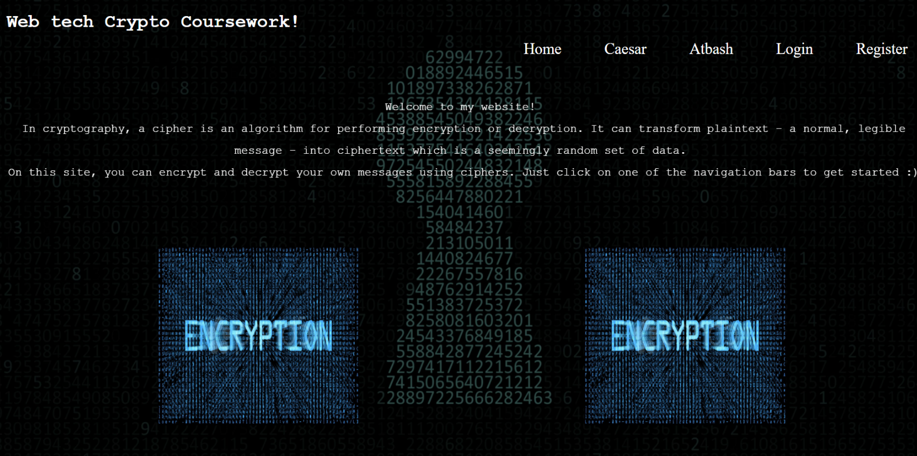

**Implementation:**

In the end, I wasn’t able to implement all the functionality that I wanted, things such as:

* Working messaging system
* Logout system
* Allowing the user to update/change their password

I also believe that design was also part of the problem of my website and could have been improved significantly. Another functionality issue is that a user’s account is only stored for that session and is erased once the server isn’t running anymore.

**Critical Evaluation:**

The specification of this task assignment was to implement a server that would allow users to register an account and login into the website, and allow them to send and receive ciphers from other users that are registered on the site.

I think in terms of learnability; this site is very simple and easy to navigate and get the job done quickly. I also consider this website to be efficient as the text is very easy to read and the encryption/decryption process is very fast. Therefore, the website meets the requirements.

However, like with everything, there is always room for improvement – even if a website meets a certain specification, adjustments can be made to improve upon them.

My functionality is the main problem of this coursework and given, another chance I would hopefully be able to rectify the mistakes I have made and implement the changes I wanted at the start.

**Personal Evaluation:**

Starting this coursework was very hard as it the materials where very vague and had to try and learn all these new technologies in a short time frame. Setting the server up was fairly easy but the login system took time trying to use sqlite3 (especially after trying another way of storing the user information)

**References**

<https://pixelz.cc/wp-content/uploads/2017/11/tech-security-illustration-code-and-key-hole-uhd-4k-wallpaper.jpg>

[https://cdn-images-1.medium.com/max/1600/0*wDm8-tNnnBkwd3Q5.jpeg](https://cdn-images-1.medium.com/max/1600/0*wDm8-tNnnBkwd3Q5.jpeg)

<https://www.youtube.com/watch?v=qaRboPK0Qnk>

<https://www.youtube.com/watch?v=hOCYNdgsUfs&t=4s>